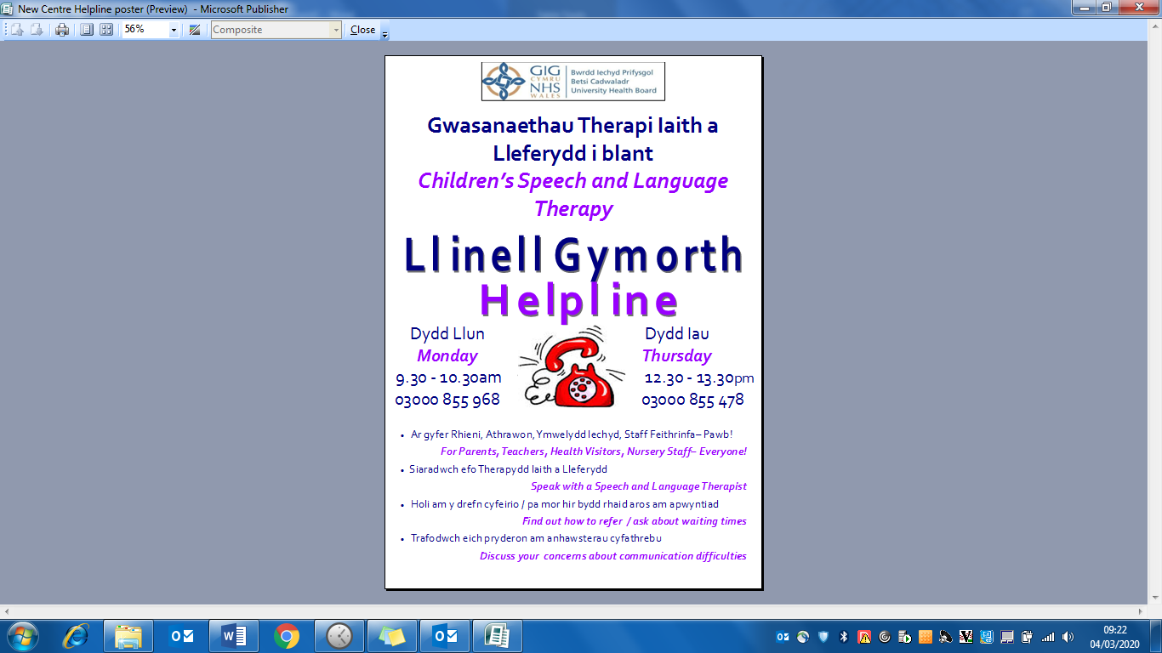

**Children’s Speech and Language Therapy**

**Helpline**



***Monday***

3pm – 4pm

03000 850095

***Thursday***

12.30pm – 13.30pm

03000 850095

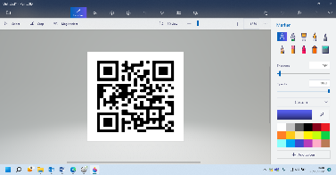[](https://www.google.co.uk/url?q=https://www.123rf.com/photo_118556689_stock-vector-laptop-a-vector-cartoon-illustration-of-a-computer-laptop-.html&sa=U&ved=0ahUKEwip5O_b14DpAhUJHxoKHbJJDzgQqoUBCB4wCw&usg=AOvVaw37vRxxXa_aPwICKOubukjb)[](https://www.google.com/url?q=https://depositphotos.com/168374298/stock-illustration-email-icon-cartoon-style.html&sa=U&ved=2ahUKEwia0oGBndHpAhVBXhoKHRhZAkYQqoUBMAN6BAgSEAE&usg=AOvVaw0jSH7ONYAjmwwhHE45THp7)

Please visit the website for further information and resources: <https://bcuhb.nhs.wales/slt>

BCU.SALTHelplineCentral@wales.nhs.uk

In order to use the email helpline please provide the child’s first name, age of child, your relationship to the child and a contact telephone number. We will use this information to respond to your query.